**Che251 Acids and Bases in Organic Chemistry Worksheet**

1. **Draw the conjugate acid of each of the following:**
2. CH3CH2OH b) CH3CH2O- c) CH3CH2NH2 d)CH3COO-
3. Write and equation showing CH3OH reacting with NH3 and indicate the acid/conjugate base and base/conjugate acid pairs.
4. Write and equation showing CH3OH reacting with HCl and indicate the acid/conjugate base and base/conjugate acid pairs.

**Which is the stronger acid?**

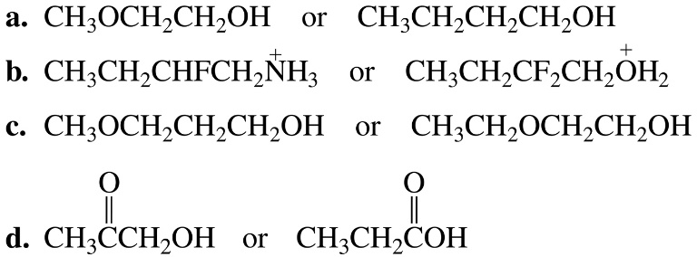

**Which is the stronger acid and why?**

